Technical Design Document

for

YouTunes

Keegan Jones

CSD – 460

10/19/2021

1. **Introduction**
   * **1.1 Purpose**

The goal of this YouTunes program is to create a program for users to create a unique and personalized list of music to listen to.

* + **1.2 Terminology**
  + **1.3 User Personas**

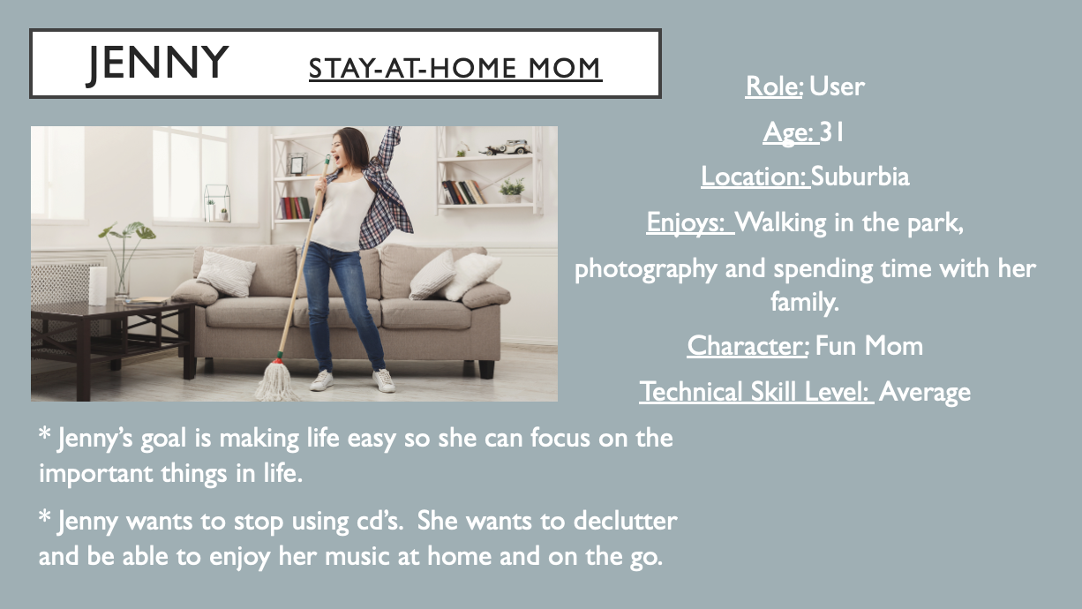

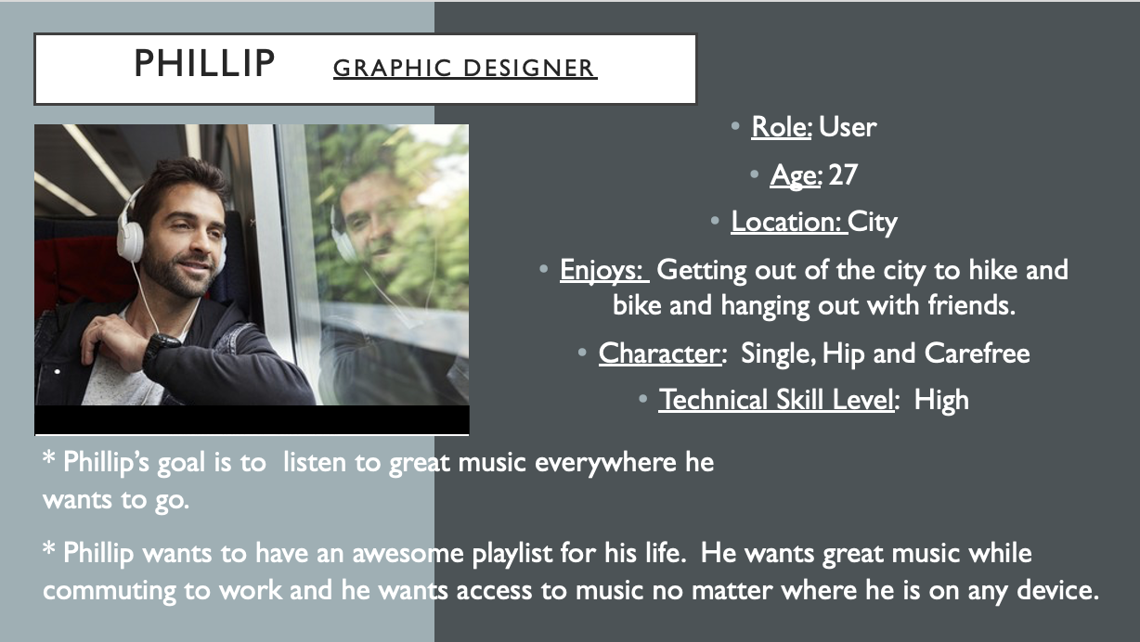

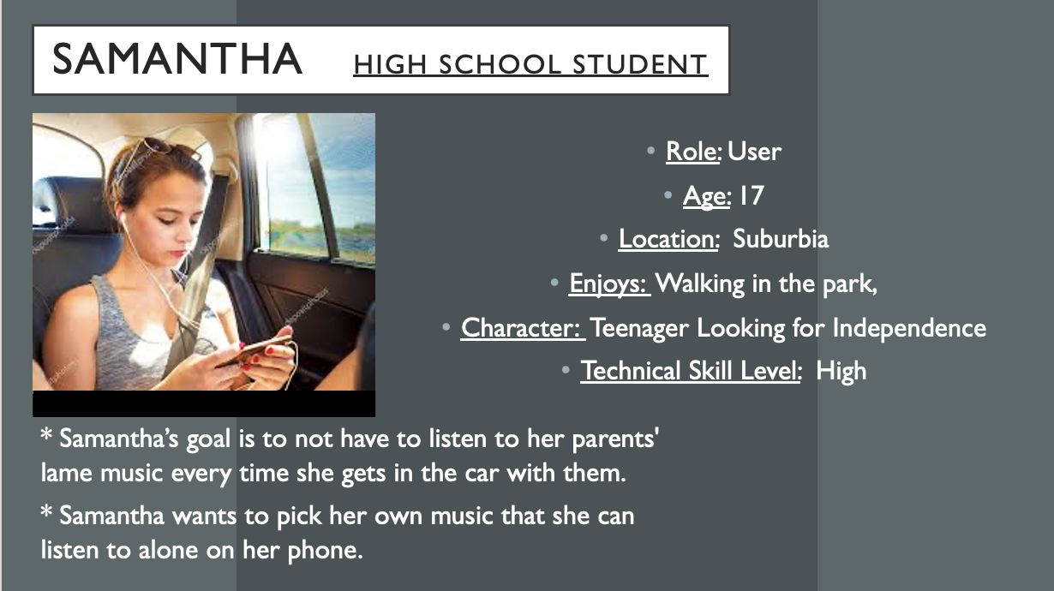

* + **1.4 User Stories**

|  |  |
| --- | --- |
|  | Stories |
| Jenny #1 | As a user Jenny wants it to be very simple to add music to her list, too many steps will make her loose interest. |
| Jenny #2 | As a user Jenny wants to be able to read a small description of the artist and or album. |
| Jenny #3 | As a user Jenny wants to understand any errors she may run into, jargon laden error messages mean nothing to her and cause frustration. |
| Jenny #4 | As a user Jenny wants intuitive navigation of the program because she does ok with technology but isn’t great with it. |
| Jenny #5 | As a user Jenny wants the ability to scroll through all available music so that she can pick what she likes without having to think of songs she likes. |
|  |  |
| Phillip #1 | As a user Phillip wants to be able to view new artist suggestions. |
| Phillip #2 | As a user Phillip wants an attractive interface because he appreciates artistic design. |
| Phillip #3 | As a user Phillip wants to view the album cover. As a graphic designer her appreciates the cover art. |
| Phillip #4 | As a user Phillip wants to jump on the program and easily and quickly add music. He is busy and doesn’t want to waste time jumping through unnecessary hoops. |
| Phillip #5 | As a user Phillip wants to be able to view by song title as it is the most direct route to finding the music he wants. |
|  |  |
| Samantha #1 | As a user Samantha wants to view by album so that she can pick and choose her favorite songs from each album. |
| Samantha #2 | As a user Samantha wants to be able to view available songs by artist name. |
| Samantha #3 | As a user Samantha wants to be able to remove songs from her music list easily because she gets tired of songs after listening to them very many times. |
| Samantha #4 | As a user Samantha wants to be able to view by genre to help her build her music list. |
| Samantha #5 | As a user Samantha wants to easily view her current music list so that her parents can monitor her music selections. |

* + **1.5 Work Estimations**

|  |  |
| --- | --- |
|  | Work Estimate/Story Points |
| Jenny #1 | 5 |
| Jenny #2 | 3 |
| Jenny #3 | 8 |
| Jenny #4 | 5 |
| Jenny #5 | 3 |
|  |  |
| Phillip #1 | 5 |
| Phillip #2 | 8 |
| Phillip #3 | 3 |
| Phillip #4 | 5 |
| Phillip #5 | 3 |
|  |  |
| Samantha #1 | 3 |
| Samantha #2 | 3 |
| Samantha #3 | 1 |
| Samantha #4 | 3 |
| Samantha #5 | 5 |

1. **Design**
   * **2.1 PrototypesA picture containing diagram

     Description automatically generatedTable

     Description automatically generated**

* + **2.2**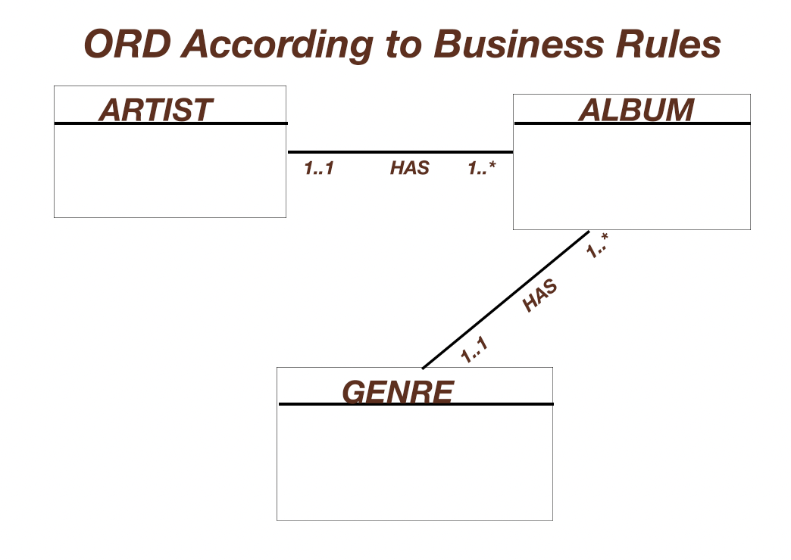

1. **QA Testing**
   * **3.1 QA Test Plan**
   * **3.2 Unit Tests**

|  |  |
| --- | --- |
| **Project:** **YouTunes** |  |
| **Course: CSD 460** |  |
| **Description: Music Store** |  |
| **Date: 2021/10/25** |  |
| **Version: 1** |  |

**TABLE OF CONTENTS**

**Test that the website opens correctly.** 2

**Test that the links highlight on hover.** 3

**Test links on Navigation bar from home to next page.** 4

**Test that the ‘Add New Album’ button on the home page works correctly.** 7

**Test that the ‘Edit’ button on the Artist List works correctly.** 10

**Test that the ‘delete’ button on the Artist List works correctly.** 13

|  |  |  |  |  |
| --- | --- | --- | --- | --- |
| Test 1 | **Test that the website opens correctly.** | | | |
|  | **Test Objective: Verifies the website landing page will open.** | **Developer:**  **Date tested: 2021/10/25** | **Peer tester:**  **Date tested:** <yyyy/mm/dd> | |
| **Step** | **Action** | **Expected results:** | **Developer pass/fail** | **Tester pass/fail** |
| 1 | If I open a new web browser, | I expect that a new browser will open. | yes | <yes/no> |
| 2 | If I type in ‘http://localhost:7070/youtunes/’, | I expect the landing page for the website to open with no errors. | yes | <yes/no> |
| 3 |  |  |  |  |
| 4 |  |  |  |  |
| 5 |  |  |  |  |
| **Comments** | I opened a new Google Chrome browser on my mac, and it opened fine. I then typed in the ‘http://localhost:7070/youtunes/’ and the web page loaded with no errors. However, the images did not open correctly. There is just an image icon.  Graphical user interface, text, application, email  Description automatically generated | | | |

|  |  |  |  |  |
| --- | --- | --- | --- | --- |
| Test 2 | **Test that the links highlight on hover.** | | | |
|  | **Test Objective: To make sure that the links on the Top Navigation bar change color on hover.** | **Developer:**  **Date tested: 2021/10/26** | **Peer tester:**  **Date tested:** <yyyy/mm/dd> | |
| **Step** | **Action** | **Expected results:** | **Developer pass/fail** | **Tester pass/fail** |
| 1 | If I open a new web browser, | I expect a new browser to open. | yes | <yes/no> |
| 2 | If I type in ‘http://localhost:7070/youtunes/’, | I expect the landing page for the website to open with no errors. | yes | <yes/no> |
| 3 | If I hover my mouse over various links on the top navigation bar, | I expect the links to be highlighted in a different color. | yes | <yes/no> |
| 4 |  |  |  |  |
| 5 |  |  |  |  |
| **Comments** | I was able to open a new web browser and put type in the url. Once I pressed enter, the website loaded and opened correctly with no errors. When I used my mouse to hover over the various links on the top navigation bar the links highlighted correctly as expected. Please see screenshot below.  Graphical user interface, website  Description automatically generated | | | |

|  |  |  |  |  |
| --- | --- | --- | --- | --- |
| Test 3 | **Test links on Navigation bar from home to next page.** | | | |
|  | **Test Objective: From the home page can you click on a navbar link and have it take you to the correct page.** | **Developer:**  **Date tested:** 2021/11/3 | **Peer tester:**  **Date tested:** <yyyy/mm/dd> | |
| **Step** | **Action** | **Expected results:** | **Developer pass/fail** | **Tester pass/fail** |
| 1 | If I open a new web browser, and type in ‘http://localhost:7070/youtunes/’, | I expect a new browser to open and the landing page for the website to open with no errors. | yes | <yes/no> |
| 2 | If I hover my mouse over the ‘Artists’ link on the top navigation bar, | I expect the link to be highlighted in a different color. | yes | <yes/no> |
| 3 | If I then click on the ‘Artists’ link, | I expect the ‘Artist’ page with the Artist List to open with no errors. | yes | <yes/no> |
|  |  |  |  |  |
|  |  |  |  |  |
| **Comments** | I was able to successfully open a browser and type in the url address and the page loaded correctly. I was then able to hover over the ‘Artists’ link on the navbar and it was highlighted on hover. When I clicked on the ‘Artists’ link it took me to the artist page with the Artist List. I did not get any errors.  Graphical user interface, website  Description automatically generated  Graphical user interface, website  Description automatically generated  Graphical user interface, website  Description automatically generated | | | |

|  |  |  |  |  |
| --- | --- | --- | --- | --- |
| Test 4 | **Test that the ‘Add New Album’ button on the home page works correctly.** | | | |
|  | **Test Objective: To ensure that if I click on the ‘Add New Album’ button on the home page that it will load a new page with the New Album Form, without errors.** | **Developer:**  **Date tested:** 2021/11/3 | **Peer tester:**  **Date tested:** <yyyy/mm/dd> | |
| **Step** | **Action** | **Expected results:** | **Developer pass/fail** | **Tester pass/fail** |
| 1 | If I open a new web browser, and type in ‘http://localhost:7070/youtunes/’, | I expect a new browser to open and the landing page for the website to open with no errors. | yes | <yes/no> |
| 2 | If I click on the ‘Add New Album’ button on the home page, | I expect a new page to load with a New Album Form, without errors. | yes | <yes/no> |
| 3 | If I click on the various text fields of the form, | I expect to be able to type into each field and use the drop-down selector. | yes | <yes/no> |
| 4 | If I click the ‘save’ button on the form, | I expect the form to save a new album to the database. | yes | <yes/no> |
|  |  |  |  |  |
| **Comments** | I was able to successfully open a browser and type in the url address and the page loaded correctly. I then clicked on the ‘Add New Album’ button and a new page loaded with a New Album Form. I was able to type into the form and select from a drop-down menu to select a genre. I then clicked the save button and was returned to the home page and the new album was displayed. There needs to be additional work on how to make it display in a better way, but the information was there.  Graphical user interface, website  Description automatically generated  Graphical user interface, text, website  Description automatically generated  Graphical user interface, website  Description automatically generated  Graphical user interface, website  Description automatically generated | | | |

|  |  |  |  |  |
| --- | --- | --- | --- | --- |
| Test 5 | **Test that the ‘Edit’ button on the Artist List works correctly.** | | | |
|  | **Test Objective: To test that the ‘Edit’ button will allow you to edit the name of the artist on the Artist List without errors.** | **Developer:**  **Date tested:** 2021/11/5 | **Peer tester:**  **Date tested:** <yyyy/mm/dd> | |
| **Step** | **Action** | **Expected results:** | **Developer pass/fail** | **Tester pass/fail** |
| 1 | If I open a new web browser, and type in ‘http://localhost:7070/youtunes/’, | I expect a new browser to open and the landing page for the website to open with no errors. | yes | <yes/no> |
| 2 | If I click on the ‘Artists’ link on the navbar, | I expect the Artists page to load and display the Artist List with no errors. | yes | <yes/no> |
| 3 | If I click the ‘Edit’ button next to one of the artists listed, | I expect a page to load with an Artist Details Form with no errors. | yes | <yes/no> |
| 4 | If I click in one of the form text boxes, | I expect to be able to type into the text box to make a change to the artist’s name. | yes | <yes/no> |
| 5 | If I click the save button, | I expect to be taken back to the Artists page with the Artist List that reflects the edit to the name that I made with no errors. | yes | <yes/no> |
| **Comments** | I was able to successfully open a browser and type in the url address and the page loaded correctly. I then clicked on the ‘Artists’ link on the navbar and a new page loaded, displaying the Artist List with no errors. I then clicked the ‘Edit’ button next to the artist, Pearl Jam. A new page loaded with an Artist Details form with no errors. I was then able to make a change to the artist name. When I clicked the ‘save’ button, I was returned to the ‘Artists’ page and the Artist List reflected the edit to the name that I made with no errrors.  Graphical user interface, website  Description automatically generatedGraphical user interface, text, application, email  Description automatically generated  Graphical user interface, text, application  Description automatically generated  Graphical user interface, website  Description automatically generated | | | |

|  |  |  |  |  |
| --- | --- | --- | --- | --- |
| Test 6 | **Test that the ‘delete’ button on the Artist List works correctly.** | | | |
|  | **Test Objective: To ensure that the ‘delete’ button on the Artist List will function correctly, deleting an artist from the list with no errors.** | **Developer:**  **Date tested:** 2021/11/5 | **Peer tester:**  **Date tested:** <yyyy/mm/dd> | |
| **Step** | **Action** | **Expected results:** | **Developer pass/fail** | **Tester pass/fail** |
| 1 | If I open a new web browser, and type in ‘http://localhost:7070/youtunes/’, | I expect a new browser to open and the landing page for the website to open with no errors. | yes | <yes/no> |
| 2 | If I click on the ‘Artists’ link on the navbar, | I expect the Artists page to load and display the Artist List with no errors. | yes | <yes/no> |
| 3 | If I click the ‘delete’ button next to one of the artists on the list, | I expect the artist’s name on the list to disappear from the list with no errors. | yes | <yes/no> |
|  |  |  |  |  |
|  |  |  |  |  |
| **Comments** | I was able to successfully open a browser and type in the url address and the page loaded correctly. I then clicked on the ‘Artists’ link on the navbar and a new page loaded, displaying the Artist List with no errors. I then clicked the delete button next to the first artist on the list. The artist was removed from the list correctly with no errors.  Graphical user interface, website  Description automatically generated  Graphical user interface, website  Description automatically generated  Graphical user interface, text, application, email, website  Description automatically generated | | | |